IT463

Risk Management Plan

**And**

**EVA**

GradBird Consultants



# CONTENTS:

CONTENTS: 2

PROJECT DESCRIPTION: 3

MEASURABLE ORGANIZATIONAL VALUE (MOV): 4

DESIRED VALUE OF IMPACT: 5

ORIGINAL PROJECT SUMMARY REPORT (BASELINE REPORT) 6

BASELINE TOTAL COST OF OWNERSHIP (TCO): 7

BASELINE BUDGET: 8

BASELINE WBS: (WORK BREAKDOWN STRUCTURE-ORIGINAL PROJECT PLAN): 9

BASELINE GANTT CHART: 11

BASELINE CRITICAL PATH: 12

BASELINE COST OF RESOURCES: 13

PROJECT RISK ANALYSIS AND PLAN 16

REVISED PROJECT SUMMARY REPORT 18

REVISED TOTAL COST OF OWNERSHIP (TCO): 19

REVISED BUDGET: 21

REVISEDWORK BREAKDOWN STRUCTURE: 22

REVISEDGANTT CHART: 23

REVISED CRITICAL PATH: 25

REVISED COST OF RESOURCES: 26

EARNED VALUE REPORT (EVR) 29

PROPOSED SOLUTION /RECOMMENDATION 30

PROJECT NAME: IT Strategic plan, City of Mequon

TEAM NAME: GradBird Consultants

**Project Leader:** Eric Agyemang

# PROJECT DESCRIPTION:

The City of Mequon, WI, is the largest city in Ozaukee County and the third largest city in land area in the state of Wisconsin. The City of Mequon provides public and information services to the citizens that enhance the quality of life in the community. The city has 4 primary facilities, namely City Hall, Public Safety Building, East Side Fire Station, and Public Works Safety. These facilities have various departments which include City Administrator's Office, City Clerk's Office, Finance, Public Works, Community Development, Police Department, and Fire Department.

This project is started in request to the City of Mequon seeking assistance in developing the ICT Infrastructure Plan. The proposed plan focuses on developing an Information Technology Plan that guides the organization in planning, designing, implementing, and maintaining the present and future technology requirements, so the city will have a more reliable, available, secure, and improved usability in a cost-effective way over the next 3-4 years. As a result, citizens and employees will be able to enjoy and use the system more effectively.

The budget for this project has been reduced from $110,000 to $88,000. An IT Security Consultant has been added to enhance system security. The addition of the IT Security Consultant has brought the project over budget and over schedule. The project includes a proposed solution that will bring the project back within the requested schedule and under the revised budget.

# MEASURABLE ORGANIZATIONAL VALUE (MOV):

The City of Mequon is striving to improve and maintain the current IT technologies used by the city. The project will focus upon creating a cost-effective plan with the highest benefits. A cost-effective plan will efficiently use the city resources to improve and maintain the existing IT technologies during the next 4 years. Incremental changes to the buildings Wi-Fi routers and network switches will upgrade the wireless and wired networks resulting in higher wireless network speed and while also maintaining wired network stability. To ensure reliability, the workstations and laptops will be incrementally replaced with newer and more powerful workstations. All backup data will be relocated from the backup servers to the cloud to ensure that it is always available, free of viruses, threats, and more secure (AWS guarantees 100% security). Relocating the backup data to the cloud is also a very cost-effective move. A software security company will be added to improve on-premises systems security. The servers will be replaced to ensure highly operational servers with continued reliability. All current software licenses will be renewed. The purpose of these cost-effective upgrades is to provide a highly beneficial system so that the city can continue to provide cost-effective services to the citizens of Mequon.

The table below describes the Desired Areas of Impact:

|  |  |  |  |
| --- | --- | --- | --- |
| Organizational Impact | Value | Metric | Time Frame |
| Customer | Provide a better IT System to the city so the citizens can continue having low-cost services | Fewer complaints from citizens.  10% reduction  (current count- 200 complaints estimated)    Improving citizen satisfaction with website access and interaction  (increased annual survey satisfaction numbers) | Annual Survey  Annual Survey |
| Financial | Effectively spending the city resources to improve or maintain the current IT system | Within Budget  $110,000  with possible savings of 10% | Annual Budget |
| Operational | A more efficient IT system that is more available, reliable, secure and faster. | Reduced downtimes by 10%, improved performance (2x faster), higher usability (increase in citizen usage by 10% and increased staff satisfaction), better security (AWS guarantees 100% security) | Annual Survey | |

The City of Mequon serves more than 24,000 citizens. The city strives to provide quality services to the citizens while maintaining low tax rates. The plan focuses upon implementing upgrades and improvements that will be cost-effective while improving efficiency, security, and reliability during the next 4 years. The plan includes considerations for anticipated city growth and unanticipated changes.

# DESIRED VALUE OF IMPACT:

The planned IT system changes will decrease the number of IT help desk complaints because the upgraded and improved systems will be easier to use and more stable. The upgraded system will be more secure, which will reduce security threats and improve reliability. The project team anticipates an improved IT system will increase user satisfaction, which means more citizens will utilize online resources. The success of the plan will be validated by annual surveys of citizens and city employees verifying satisfaction with the IT system changes.

# ORIGINAL PROJECT SUMMARY REPORT (BASELINE REPORT)

The following table presents the original (Baseline) project summary report with details of project attributes obtained from the Microsoft Project.

|  |  |  |  |
| --- | --- | --- | --- |
| Dates | | | |
| Start | 09/02/21 | Finish | 12/16/21 |
| Baseline start | 09/02/21 | Baseline finish | 12/16/21 |
| Actual start | NA | Actual finish | NA |
| Variance | 0 days | Finish Variance | 0 days |

|  |  |  |  |
| --- | --- | --- | --- |
| Duration | | | |
| Schedule | 74 days | Remaining | 74 days |
| Baseline | 74 days | Actual | 0 days |
| Variance | 0 days | Percent complete | 0% |

|  |  |  |  |
| --- | --- | --- | --- |
| Work | | | |
| Schedule | 1,216 hours | Remaining | 1,216 hours |
| Baseline | 1,216 hours | Actual | 0 hours |
| Variance | 0 hours | Percent complete | 0% |

|  |  |  |  |
| --- | --- | --- | --- |
| Costs | | | |
| Schedule | $86,375 | Remaining | $86,375 |
| Baseline | $86,375 | Actual | $0 |
| Variance | $0 |  |  |

|  |  |  |  |
| --- | --- | --- | --- |
| Task status | | Resources status | |
| Tasks not yet started | 60 | Work resources | 7 |
| In progress | 0 | Over allocated work resources | 0 |
| Completed | 0 | Material resources | 6 |

Total tasks 60

The total duration for the tasks is 74 days and the expected budget is $86,375.

# BASELINE TOTAL COST OF OWNERSHIP (TCO):

The following table lists the baseline Total Cost of Ownership:

|  |
| --- |
| **Total Cost of Ownership (TCO)** |

|  |  |  |
| --- | --- | --- |
| Resource | Description | Proposed Plan Cost |
| Salaries  Personnel  IT Dept Salaries: | Project Manager  (1 person*$48/hr. *420 hrs.)  Tech Team  (3 people*$32/hr.  Tech 1 for 180 hrs.  Tech 2 for 205 hrs.  Tech 3 for 210 hrs.)  TOTAL (**t1**)  City Dept Salaries:    1 full time IT coordinator  (2 weeks, 80 hrs. * $30)  Public safety IT specialist  (2 weeks, 80 hrs. * $23)  TOTAL(**t2**) | $20,160  $5,760  $6,560  $6,720  $19,040  **$39,200**  $2,400  $1,840  **$4,240**  **$43,440** |
| Server | Replacing 8 servers, servers 2 per year  $1,780 per server | $3,560 |
| Workstation Desktops | Replacing 5 per year,  $1,274 per desktop workstation | $6,370 |
| Workstation Laptops | Replacing 5 per year,  $1,309 per laptop workstation | $6,545 |
| Wireless Network | Replacing facilities routers  1 facility per year, 5 per year, $224 per router | $1,120 |
| Wired Network | Replacing 2 switches per year, $442 per switch | $884 |
| Storage | Replacing backup servers to store data into cloud, 1TB/ month | $48 |
| Software | Maintaining current software licensing | $11,984 |
| Training | 2 days on site training,  $500 per day (every year) | $1,000 |
| Maintenance and Support | 1 week, 40 hrs. * $30 per hour    TOTAL(**t3**) | $1,200      **$32,711** |
| GRAND TOTAL | **t1**+**t2**+**t3** | **$76,151** |

From the TCO table above, the total amount of $76,151 is within the budgeted amount of $110,000. Each resource cost is listed and the per unit cost of each resource is supported by a source link shown in the cost of resources table below the budget. The cost overview given by the WBS has exactly allocated hours to the personnel, but the TCO also has extra padding hours for the personnel which is the reason for the discrepancy in the values.

# BASELINE BUDGET:

Below is the table that shows the baseline budget from the first year to the fourth year.

|  |  |  |  |  |
| --- | --- | --- | --- | --- |
|  | Year 1 | Year 2 | Year 3 | Year 4 |
| Funds | $110,000 | $110,000 | $110,000 | $110,000 |
| Project Team Salaries | ($39,200) | ($39,200) | ($39,200) | ($39,200) |
| IT Dept Salaries | ($4,240) | ($4,240) | ($4,240) | ($4,240) |
| Office Supplies | ($2,000) | ($2,000) | ($2,000) | ($2,000 |
| Proposed Plan | ($32,711) | ($32,711) | ($32,711) | ($32,711) |
| Contingency | ($10,000) | ($10,000) | ($10,000) | ($10,000) |
| Total Surplus | $22,249 | $22,249 | $22,249 | $22,249 |

From the budget table above, a yearly fund of $110,000 was allocated for the project, out of which all costs for each year were deducted, which includes the contingency amount of $10,000. The total surplus for each year was ascertained by deducting the total annual costs from the annual fund. A surplus of $22,249 was obtained for each year.

# BASELINE WBS: (WORK BREAKDOWN STRUCTURE-ORIGINAL PROJECT PLAN):

The deliverable structure chart was built based on the Project Life Cycle. Each phase of Project Life Cycle is assigned as a Task in our Work Breakdown Structure, along with the duration required to complete the task. We have created the subtasks by taking MOV into consideration so that the project can adhere to the MOV. The Schedule includes the standard 8-hour work time and excludes special holidays and weekends. The resources are assigned to each task, and the cost is calculated based on the number of days the task would take to complete.

The WBS includes tasks with subtasks and the milestones. Each task includes the duration in days required to complete the task and the necessary resources. Some of the tasks have dependencies with listed predecessors. Every task is Start-to-Finish.

Below is the illustrated baseline WBS.

The above WBS has no over-allocated resources as the resources were scheduled accordingly to avoid any conflicts and to balance the workload among the team. This serves as the baseline for revising the original project plan.

# BASELINE GANTT CHART:

The baseline Gantt Chart illustrates the annual phases of the 4-year original project.

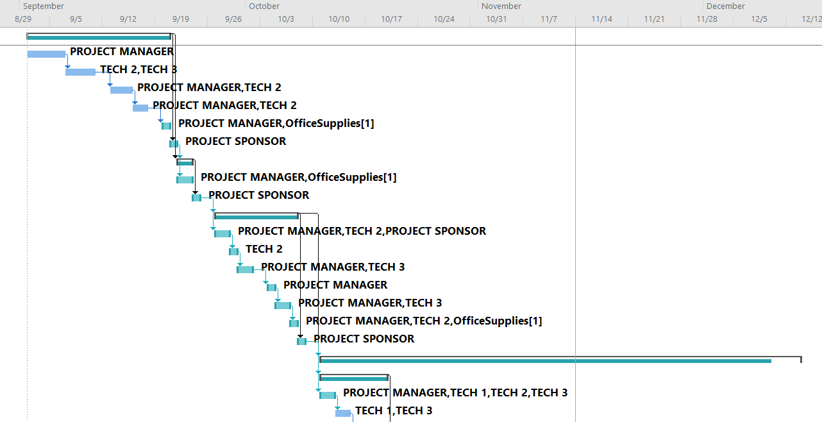

# BASELINE CRITICAL PATH:

The original project has multiple critical paths shown below. Each of those paths (except the major critical path) starts but does not finish at Project Evaluation phase. The critical path is important because it represents the longest path and the shortest period in which the project may be completed.

# BASELINE COST OF RESOURCES:

Below is the table that describes the cost of resources for the original project.

|  |  |  |
| --- | --- | --- |
| Resource | Cost | Source |
| Project Manager | **$48 per hour** | [**https://www.zippia.com/software-project-manager-jobs/salary/**](https://www.zippia.com/software-project-manager-jobs/salary/) |
| Tech Team (Tech 1, Tech 2 , Tech 3) | **$32 per hour** | [**https://www.salary.com/research/salary/recruiting/tech-analyst-hourly-wages**](https://www.salary.com/research/salary/recruiting/tech-analyst-hourly-wages) |
| IT Co-Ordinator | **$30 per hour** | [**https://www.zippia.com/technology-coordinator-jobs/salary/**](https://www.zippia.com/technology-coordinator-jobs/salary/) |
| Public Safety IT Specialist | **$23 per hour** | [**https://www.governmentjobs.com/jobs/3256500-0/public-safety-specialist-ft**](https://www.governmentjobs.com/jobs/3256500-0/public-safety-specialist-ft) |

|  |  |  |
| --- | --- | --- |
| Resource | Cost | Source |
| WIRELESS NETWORK  AX3600 Wi-Fi 6 Access Point (WAX218PA) | $180 per Router | <https://www.netgear.com/business/wifi/access-points/listing-filter/multigig-2/under-275/ax3600/> |
| WIRED NETWORK  Cisco® Catalyst® Digital Building Series Switch PoE | $442 per device | <https://networkdevicesinc.com/products/cdb-8p?variant=32781089570919>  <https://www.cisco.com/c/en/us/products/collateral/switches/catalyst-digital-building-series-switches/datasheet-c78-738206.html> |
| WORKSTATIONS  -HP Z2 Tower G5 Workstation  -Dell Latitude 5400  Chromebook  Workstation Laptops | $1,274 per workstation  $1,309 per laptop | <https://www.hp.com/us-en/shop/pdp/hp-z2-tower-g5-workstation>  <https://www.dell.com/en-us/work/shop/dell-laptops-and-notebooks/latitude-5400-chromebook-enterprise/spd/latitude-14-5400-chrome-laptop/xctolc540014us3> |
| SERVER  HP ProLiant ML350 Gen10 Server | $1,780 per server | Specs  [HPE ProLiant ML350 Gen10 Server (Quick Specs/a00021852enw.pdf)](https://h20195.www2.hpe.com/v2/GetDocument.aspx?docname=a00021852enw)  Cost  [HPE ProLiant ML350 Gen10 server | HPE Store US](https://buy.hpe.com/us/en/servers/tower-servers/proliant-ml300-servers/proliant-ml350-server/hpe-proliant-ml350-gen10-server/p/1010192786) |
| BACKUP STORAGE  Cloud (AWS- Glacier) | Glacier  $0.004/ GB  Per month | <https://aws.amazon.com/s3/pricing/> |
| Microsoft Office 365 | $580 per year | <https://www.mychoicesoftware.com/products/microsoft-office-professional-plus-2019-open-government> |
| MS Windows Server (OS)  MS Windows 10 pro | $1,500 per year  $199 per year | <https://www.microsoft.com/en-ie/windows-server/pricing>  <https://www.microsoft.com/en-us/d/windows-10-pro/df77x4d43rkt?activetab=pivot:overviewtab> |
| Municode | $350 per year | <https://www.municode.com/documents> |
| Arc GIS | $2,600 per year | <https://www.esri.com/en-us/arcgis/products/arcgis-desktop-subscription> |
| AutoCAD Civil 3D  AutoCAD LT | $2,315 per year  $440 per year | <https://www.autodesk.ae/products/civil-3d/overview#:~:text=The%20price%20of%20an%20annual,3D%20subscription%20is%20US%246%2C250%20>  <https://www.autodesk.com/products/autocad-lt/overview> |
| Watchguard | $500 per year | <https://www.cdw.com/product/watchguard-total-security-suite-subscription-license-renewal-upgrade-li/4242815> |
| Others (Accela, Black Bear, Prophoenix, Hypercaster, Infoview) | $3,500 | Estimation based on existing software prices |
| Office Supplies | $2,000 per year | <https://www.officedepot.com/a/products/563024/Office-Depot-Brand-EnviroCopy-Paper-Letter/>  <https://www.walmart.com/ip/SKILCRAFT-NSN4936006-Employee-Start-up-Office-Kit-1-Kit/34911380?wmlspartner=wlpa&selectedSellerId=0> |

NOTE: The MS Project File of the Baseline plan is attached along with this document. Quoted prices might change with time depending on the vendor.

# PROJECT RISK ANALYSIS AND PLAN

The Risks were identified for each of the PLC phases.

**Risk Identification Framework**

|  |  |  |  |
| --- | --- | --- | --- |
| **RISK** | **RISK DESCRIPTION** | **STRATEGY DESCRIPTION** | **OWNER** |
| PHASE 1  *Project Initialization*    Budget  Changes | Budget reductions will reduce the scope and time. If budget increases, scope and time increases accordingly.  It is unknown-known. The source is internal and emerges from people (the project sponsor and project manager) | The project team will initialize the project under budget. If the budget decreases, then hours of work will be decreased, and costs will be decreased. If the budget increases, the surplus will be applied to increase the scope proportionally. The budget will also include a considerable contingency amount to offset minor budget changes. | Project Sponsor and  Project Manager |
| PHASE 2  *Project Charter and Scope Management Plan*    Changed Scope | If the project sponsor widens or narrows the scope during the project charter and scope management phase, the scope management plan will have to be adjusted.  It is unknown-known. The source is internal and emerges from people (the project sponsor) | Having timely meetings with the stakeholder to discuss any possible changes will allow our team to have time to manage changes. | Project Manager |
| PHASE 3  *Project Execution and Control*  Key Personnel Leaves Project  (IT Security Consultant) | If the IT Security Consultant leaves the project, the project’s security aspects might be compromised and difficult to complete within schedule.  It is unknown-known. The source is internal and emerges from people (IT Security Consultant, project sponsor) | The project team will be in agile mode to offset the  IT Security Consultant absence. Schedule and tasks will be reassigned to meet security needs. | Project Manager, Project Team |
| PHASE 4  *Close Project*  Failure to Meet Schedule | If the project team fails to meet schedule, the closure milestone might be delayed in completion. This may lead to a delay in the subsequent phases.  It is known-unknown. The source is internal/external and emerges from people, organizational, process and technology. | The team will schedule plans carefully with slacks and prioritize maintaining the schedule. | Project Team  and Stakeholder |
| PHASE 5  *Evaluating the Project Success*  Survey Process Failures | Our project evaluation is dependent on the successful survey process. Delayed surveys and inaccurate responses will adversely affect the evaluated results.  It is known-known. The source is internal/external and it emerges from people, process. | The project team will send follow up emails for clarification on responses and notifications to non-responses. These will ensure more accurate responses and a better evaluation. | Project Team |

# 

# REVISED PROJECT SUMMARY REPORT

The following table presents the revised (over budget) project summary report with details of project attributes obtained from the Microsoft Project.

|  |  |  |  |
| --- | --- | --- | --- |
| Dates | | | |
| Start | 09/02/21 | Finish | 12/30/21 |
| Baseline start | 09/02/21 | Baseline finish | 12/16/21 |
| Actual start | NA | Actual finish | NA |
| Variance | 0 days | Finish Variance | 10 days |

|  |  |  |  |
| --- | --- | --- | --- |
| Duration | | | |
| Schedule | 84 days | Remaining | 84 days |
| Baseline | 74 days | Actual | 0 days |
| Variance | 10 days | Percent complete | 0% |

|  |  |  |  |
| --- | --- | --- | --- |
| Work | | | |
| Schedule | 1,296 hours | Remaining | 1,296 hours |
| Baseline | 1,216 hours | Actual | 0 hours |
| Variance | 80 hours | Percent complete | 0% |

|  |  |  |  |
| --- | --- | --- | --- |
| Costs | | | |
| Schedule | $89,655 | Remaining | $89,655 |
| Baseline | $86,375 | Actual | $0 |
| Variance | $3,280 |  |  |

|  |  |  |  |
| --- | --- | --- | --- |
| Task status | | Resources status | |
| Tasks not yet started | 68 | Work resources | 8 |
| In progress | 0 | Over allocated work resources | 0 |
| Completed | 0 | Material resources | 6 |

The total duration for the tasks is 84 days and the expected budget is $89,655.

# 

# REVISED TOTAL COST OF OWNERSHIP (TCO):

The following table lists the revised TCO:

**Total Cost of Ownership (TCO)**

|  |  |  |
| --- | --- | --- |
| Resource | Description | Proposed Plan Cost |
| Salaries  Personnel  IT Dept Salaries:  IT Security Consultant: | Project Manager  (1 person*$48/hr *420 hrs)  Tech Team  (3 people*$32/hr  Tech 1 for 180 hrs  Tech 2 for 205 hrs  Tech 3 for 210 hrs)    TOTAL (**t1**)  City Dept Salaries:    1 full time IT coordinator  (2 weeks, 80 hrs * $30)  Public safety IT specialist  (2 weeks, 80 hrs * $23)    Security Analyst  (12 days, 96 hrs * $41)  TOTAL (**t2**) | $20,160  $5,760  $6,560  $6,720  $19,040  **$39,200**  $2,400  $1,840  $4,240 **$4,240**        $3,936 **$3,936**  **$47,376** |
| Server | Replacing 8 servers, servers 2 per year $1780 per server | $3,560 |
| Workstation Desktops | Replacing 5 per year,  $1274 per desktop workstation | $6,370 |
| Workstation Laptops | Replacing 5 per year,  $1309 per laptop workstation | $6,545 |
| Wireless Network | Replacing facilities routers  1 facility per year, 5 per year, $224 per router | $1,120 |
| Wired Network | Replacing 2 switches per year, $442 per switch | $884 |
| Storage | Replacing backup servers to store data into cloud, 1TB/ month | $48 |
| Software | Maintaining current software licensing | $11,984 |
| Training | 2 days on site training,  $500 per day (every year) | $1,000 |
| Maintenance and Support | 1 week, 40 hrs * $30 per hour    TOTAL (**t3**) | $1,200      **$32,711** |
| GRAND TOTAL | **t1**+**t2**+**t3** | **$80,087** |

From the TCO table above, the IT Security Consultant is assigned 96 hours of work which is approximately 12 days of work excluding weekends and holidays. His average hourly salary is $41 and a yearly salary of 3,936. The Grand Total amount of $80,087 is within the budgeted amount of $88,000 (Thus 20% reduction of $110,000). Each resource cost is listed and the per unit cost of each resource is supported by a source link shown in the cost of resources table below the budget. The cost overview given by the WBS has exactly allocated hours to the personnel, but the TCO also has extra padding hours for the personnel which is the reason for the discrepancy in the values.

# REVISED BUDGET:

Below is the table that shows the revised budget from the first year to the fourth year.

|  |  |  |  |  |
| --- | --- | --- | --- | --- |
|  | Year 1 | Year 2 | Year 3 | Year 4 |
| Funds | $88,000 | $88,000 | $88,000 | $88,000 |
| Project Team Salaries | ($39,200) | ($39,200) | ($39,200) | ($39,200) |
| IT Dept Salaries | ($4,240) | ($4,240) | ($4,240) | ($4,240) |
| IT Security Consultant | ($3,936) | ($3,936) | ($3,936) | ($3,936) |
| Office Supplies | ($2,000) | ($2,000) | ($2,000) | ($2,000) |
| Proposed Plan | ($32,711) | ($32,711) | ($32,711) | ($32,711) |
| Contingency | ($10,000) | ($10,000) | ($10,000) | ($10,000) |
| Total Deficit | ($4,087) | ($4,087) | ($4,087) | ($4,087) |

From the budget table above, a yearly fund of $88,000 is allocated for the project out of which all costs for each year are deducted, which includes the contingency amount of $10,000. The total deficit for each year is ascertained by deducting the total annual costs from the annual fund. A deficit of $4,087 is obtained for each year.

# REVISEDWORK BREAKDOWN STRUCTURE:

The revised WBS illustrates the annual phases of the 4-year Revised project.

The above revised WBS has no over-allocated resources as the resources were scheduled accordingly to avoid any conflicts and to balance the workload among the team. The IT Security Consultant was scheduled 80 hours annually. The addition of the IT Security Consultant made the schedule late by approximately 10 days and over budget as the new security tasks were added.

# REVISEDGANTT CHART:

The Gantt Chart illustrates the annual phases of the 4-year revised project.

# REVISED CRITICAL PATH:

The revised project has multiple critical paths. Each of those paths (except the major critical path) starts but does not finish at Project Evaluation phase. The critical path is important because it represents the longest path and the shortest period in which the project may be completed.

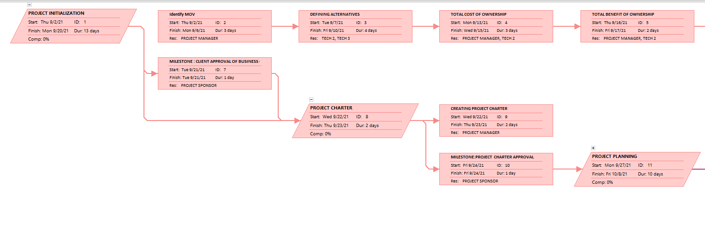

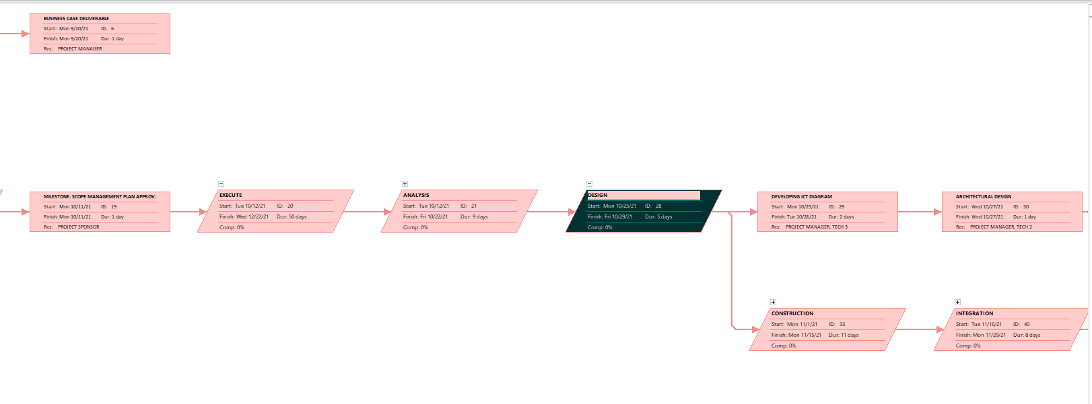

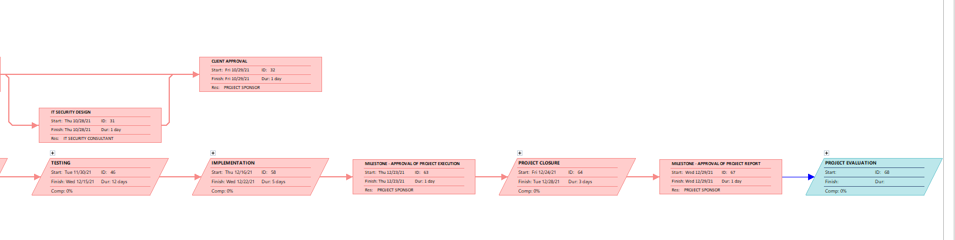

# REVISED COST OF RESOURCES:

Below is the table that describes the revised cost of resources. The quoted prices from vendors supported by the source links may change with time as vendors update costs on their websites.

|  |  |  |
| --- | --- | --- |
| Resource | Cost | Source |
| Project Manager | $48 per hour | [**https://www.zippia.com/software-project-manager-jobs/salary/**](https://www.zippia.com/software-project-manager-jobs/salary/) |
| Tech Team (Tech 1, Tech 2, Tech 3) | $32 per hour | [**https://www.salary.com/research/salary/recruiting/tech-analyst-hourly-wages**](https://www.salary.com/research/salary/recruiting/tech-analyst-hourly-wages) |
| IT Co-Ordinator | $30 per hour | [**https://www.zippia.com/technology-coordinator-jobs/salary/**](https://www.zippia.com/technology-coordinator-jobs/salary/) |
| Public Safety IT Specialist | $23 per hour | [**https://www.governmentjobs.com/jobs/3256500-0/public-safety-specialist-ft**](https://www.governmentjobs.com/jobs/3256500-0/public-safety-specialist-ft) |
| IT Security Consultant | $41 per hour | [**https://www.payscale.com/research/US/Job=Information_Technology_(IT)_Consultant/Salary**](https://www.payscale.com/research/US/Job=Information_Technology_(IT)_Consultant/Salary) |

|  |  |  |
| --- | --- | --- |
| Resource | Cost | Source |
| WIRELESS NETWORK  AX3600 Wi-Fi 6 Access Point (WAX218PA) | $180 per Router | [**https://www.netgear.com/business/wifi/access-points/listing-filter/multigig-2/under-275/ax3600/**](https://www.netgear.com/business/wifi/access-points/listing-filter/multigig-2/under-275/ax3600/) |
| WIRED NETWORK  Cisco® Catalyst® Digital Building Series Switch PoE | $442 per device | [**https://networkdevicesinc.com/products/cdb-8p?variant=32781089570919**](https://networkdevicesinc.com/products/cdb-8p?variant=32781089570919)  [**https://www.cisco.com/c/en/us/products/collateral/switches/catalyst-digital-building-series-switches/datasheet-c78-738206.html**](https://www.cisco.com/c/en/us/products/collateral/switches/catalyst-digital-building-series-switches/datasheet-c78-738206.html) |
| WORKSTATIONS  -HP Z2 Tower G5 Workstation  -Dell Latitude 5400  Chromebook  Workstation Laptops | $1,274 per workstation  $1,309 per laptop | [**https://www.hp.com/us-en/shop/pdp/hp-z2-tower-g5-workstation**](https://www.hp.com/us-en/shop/pdp/hp-z2-tower-g5-workstation)  [**https://www.dell.com/en-us/work/shop/dell-laptops-and-notebooks/latitude-5400-chromebook-enterprise/spd/latitude-14-5400-chrome-laptop/xctolc540014us3**](https://www.dell.com/en-us/work/shop/dell-laptops-and-notebooks/latitude-5400-chromebook-enterprise/spd/latitude-14-5400-chrome-laptop/xctolc540014us3) |
| SERVER  HP ProLiant ML350 Gen10 Server | $1,780 per server | Specs  [**HPE ProLiant ML350 Gen10 Server (Quick Specs/a00021852enw.pdf)**](https://h20195.www2.hpe.com/v2/GetDocument.aspx?docname=a00021852enw)  Cost  [**HPE ProLiant ML350 Gen10 server | HPE Store US**](https://buy.hpe.com/us/en/servers/tower-servers/proliant-ml300-servers/proliant-ml350-server/hpe-proliant-ml350-gen10-server/p/1010192786) |
| BACKUP STORAGE  Cloud (AWS- Glacier) | Glacier  $0.004/ GB  Per month | [**https://aws.amazon.com/s3/pricing/**](https://aws.amazon.com/s3/pricing/) |
| Microsoft Office 365 | $580 per year | [**https://www.mychoicesoftware.com/products/microsoft-office-professional-plus-2019-open-government**](https://www.mychoicesoftware.com/products/microsoft-office-professional-plus-2019-open-government) |
| MS Windows Server (OS)  MS Windows 10 pro | $1,500 per year  $199 per year | [**https://www.microsoft.com/en-ie/windows-server/pricing**](https://www.microsoft.com/en-ie/windows-server/pricing)  [**https://www.microsoft.com/en-us/d/windows-10-pro/df77x4d43rkt?activetab=pivot:overviewtab**](https://www.microsoft.com/en-us/d/windows-10-pro/df77x4d43rkt?activetab=pivot:overviewtab) |
| Municode | $350 per year | [**https://www.municode.com/documents**](https://www.municode.com/documents) |
| Arc GIS | $2,600 per year | [**https://www.esri.com/en-us/arcgis/products/arcgis-desktop-subscription**](https://www.esri.com/en-us/arcgis/products/arcgis-desktop-subscription) |
| AutoCAD Civil 3D  AutoCAD LT | $2,315 per year  $440 per year | [**https://www.autodesk.ae/products/civil-3d/overview#:~:text=The%20price%20of%20an%20annual,3D%20subscription%20is%20US%246%2C250%20**](https://www.autodesk.ae/products/civil-3d/overview#:~:text=The%20price%20of%20an%20annual,3D%20subscription%20is%20US%246%2C250%20)  [**https://www.autodesk.com/products/autocad-lt/overview**](https://www.autodesk.com/products/autocad-lt/overview) |
| Watchguard | $500 per year | [**https://www.cdw.com/product/watchguard-total-security-suite-subscription-license-renewal-upgrade-li/4242815**](https://www.cdw.com/product/watchguard-total-security-suite-subscription-license-renewal-upgrade-li/4242815) |
| Others (Accela, Black Bear, Prophoenix, Hypercaster, Infoview) | $3,500 | Estimation based on existing software prices |
| Office Supplies | $2,000 per year | [**https://www.officedepot.com/a/products/563024/Office-Depot-Brand-EnviroCopy-Paper-Letter/**](https://www.officedepot.com/a/products/563024/Office-Depot-Brand-EnviroCopy-Paper-Letter/)  [**https://www.walmart.com/ip/SKILCRAFT-NSN4936006-Employee-Start-up-Office-Kit-1-Kit/34911380?wmlspartner=wlpa&selectedSellerId=0**](https://www.walmart.com/ip/SKILCRAFT-NSN4936006-Employee-Start-up-Office-Kit-1-Kit/34911380?wmlspartner=wlpa&selectedSellerId=0) |

NOTE: The MS Project File of the Revised plan is attached along with this document. Quoted prices might change with time depending on the vendor.

.

# EARNED VALUE REPORT (EVR)

The Earned Value Report below reflects the revised changes from baseline. The status date is set to 10/12/2021, the date the IT Security Consultant began working in the analysis phase.

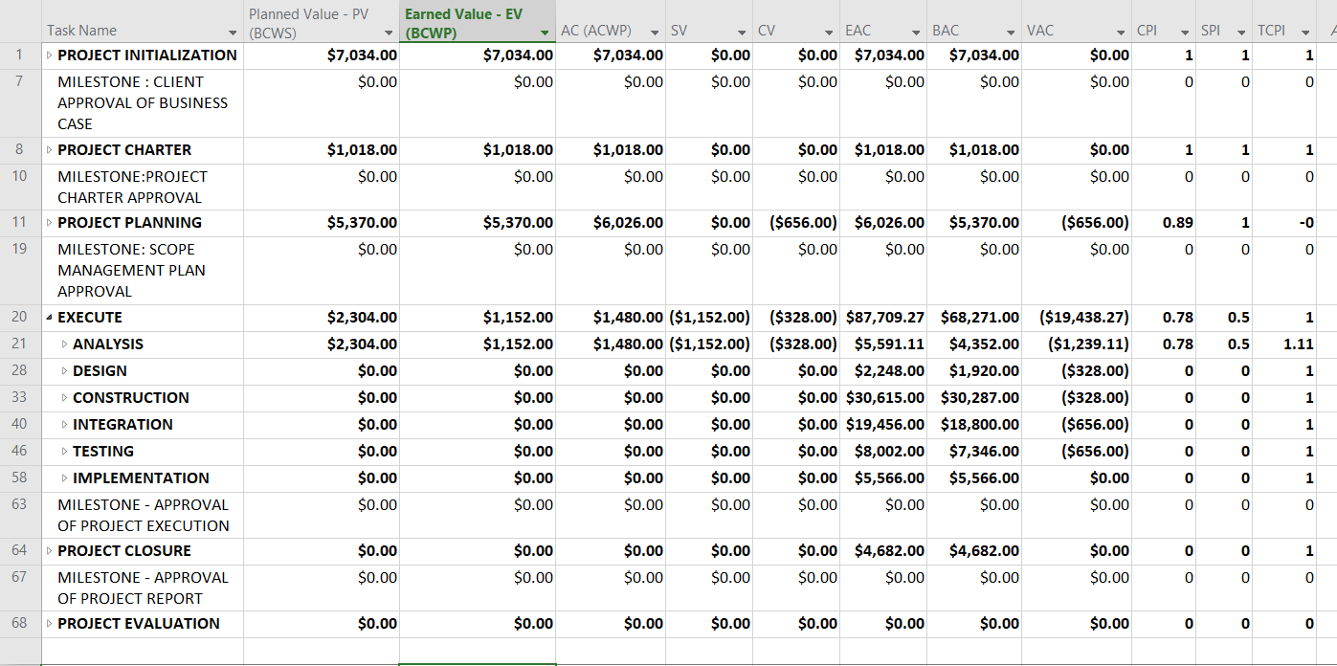

|  |  |  |  |  |  |  |  |  |
| --- | --- | --- | --- | --- | --- | --- | --- | --- |
|  | **PV** | **EV** | **AC** | **SV** | **CV** | **EAC** | **BAC** | **VAC** |
| **TOTALS** | $15,726 | $14,574 | $15,558 | ($1,152) | ($984) | $101,787.27 | $81,693 | ($20,094.27) |

The IT security consultant was assigned as follows:

Planning – 2 days (20%)

Analysis – 2 days (20%)

Design – 1 day (10%)

Construction – 1 day (10 %)

Integration – 2 days (20%)

Testing – 2 days (20%)

The addition of IT Security consultant results in a negative CV value of -$984, which indicates the project is over budget. The negative SV value of -$1,152 indicates that the project is behind schedule. The VAC is also a negative value of -$20,094.27, which indicates the project will be over budget by $20,094.27, if the current CPI of 0.78 continues. The CPI decreased during the planning and execution phases to 0.89 and 0.78 respectively. A value below 1 indicates the project is over budget; and for every $1.00 spent, only $0.89 and $0.78 respectively of work budgeted was completed. The SPI value is 0.5 which indicates the project is behind schedule; and for every $1.00 of work expected to be accomplished, only $0.50 was accomplished. The sum of EAC values is $101,787.27 (till 10/12/21) which is the estimated amount to complete the project if we believe the variance encountered so far will not continue through the remaining project schedule. The TCPI of the analysis phase is 1.11 which indicates that the project will be over budget and difficult to complete with the remaining budget. From our assessment of the TCPI, the original budget/time at completion is not reasonable.

These metrics indicate that the project is behind schedule and overbudget after adding the IT Security Consultant.

PROPOSED SOLUTION /RECOMMENDATION

Our proposed solution to the reduced schedule and budget as per client’s requirements, includes a newly revised TCO, WBS, and budget. The proposed solution TCO includes the addition of an IT Security Consultant who is assigned 110 hours of work annually. The WBS was reduced by approximately 17 days to accommodate the 10% schedule reduction. Some of the tasks were parallelized, personnel were rescheduled and reassigned to reduce the cost and schedule. The new closing date is Dec 7, which brings the project back on track. The proposed solution schedule has a 5-day slack. These changes meet the client's needs. The budget reduction in the revised plan eliminated the surplus which resulted in a $3,887 deficit. This deficit doesn’t create serious risk because the TCO and WBS will be revised in the proposed solution to reduce costs. The laptop replacements will be changed from the ***Dell 5400*** to a cheaper but comparable ***HP 15-dy2089ys 15.6*** costing $650 which will save $659 per laptop. The annual savings on the change of workstation laptops will be $3,295 annually. The workstation desktops will also be replaced from the ***Dell HP G2 Tower Z5*** to a cheaper but comparable ***HP 24-dp0158qe AiO PC*** costing $800 which will save us $474 per desktop workstation. The annual savings of the workstation desktop change will be $2,370. These reductions amount to an approximate savings of $5,665 annually. The budgeted contingency amount will also be reduced from $10,000 to $5,000. This will save $5,000 per year. The hardware savings of $5,665 combined with the $5,000 saving from the contingency amount reductions, and the WBS reduction saving of $5,986 results in a $12,564 surplus. This surplus exceeds the MOV metric of being below budget by 10%.

Note: These reductions do not result in a change of scope of the project. The values calculated are based on the TCO values. The cost overview given by the WBS has exactly allocated hours to the personnel, but the TCO also has extra padding hours for the personnel which is the reason for the discrepancy in the values.